Tariq Mehmood

Sherdil it academy

Ansible Handbook

V 1.0

Contents

Ansible 2

Key terms of Ansible: 2

Setting up Ansible 3

1. Configuring Ansible Controller 3

2. Configuring Ansible hosts 8

3. Setting up SSH 9

Ansible ad-hoc Commands 11

Ansible Modules 12

Ansible Playbook 14

Key Elements of a Playbook: 14

Extra features of a Playbook: 17

1. Condition (when): 17

2. Loops: 17

3. Tags: 18

Ansible Vault: 19

How to Use Ansible Vault: 19

# Ansible

Ansible is an open-source automation tool used to automate tasks in IT systems. It works as a remote controller for managing computers, servers, and other devices. Ansible can be used to setting up software, configuring systems, or running commands on each device.

It works by using simple ad-hoc commands or by using book of instructions called playbooks written in a language called YAML. These playbooks tell Ansible what actions to perform on host devices.

It connects to target systems via SSH or WinRM. It's agentless, meaning no special software needs to be installed on the managed nodes.

It is **push-based** this means that the **control node** pushes out configurations or tasks to the **host nodes** when you execute a ad-hoc command /playbook.

It is known for its scalability, ease of use, and ability to manage diverse environments, including servers, cloud platforms, and network devices, all while ensuring consistency and reliability across systems.

## Key terms of Ansible:

* **Ansible Controller**: The machine from which Ansible is run.
* **Module**: A unit of work Ansible uses to perform tasks.
* **Task**: A single action within a playbook.
* **Role**: A reusable set of tasks and configurations.
* **Fact**: Information about a system gathered by Ansible.
* **Play**: A section of a playbook targeting specific hosts with specific tasks.
* **Host**: A target machine managed by Ansible.
* **Inventory**: A file listing all hosts and groups of hosts for automation

# Setting up Ansible

It can be divided in 3 parts:

1. Configuring Ansible Controller

2. Configuring Ansible hosts

3. Setting up SSH

## Configuring Ansible Controller

1st we create ansible user and provide it sudo privileges with following commands (for debian based system):

Creating user ansible:

>> sudo adduser ansible

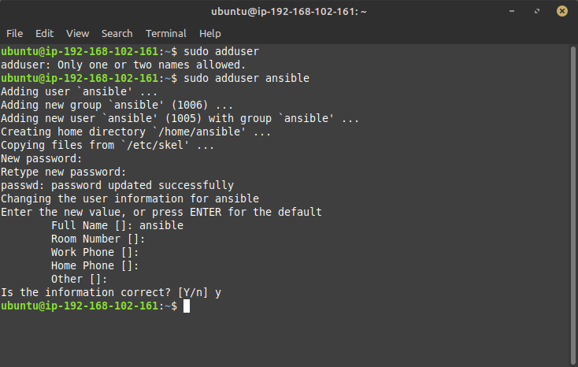

Giving ansible user sudo privileges:

>> sudo usermod -aG sudo ansible

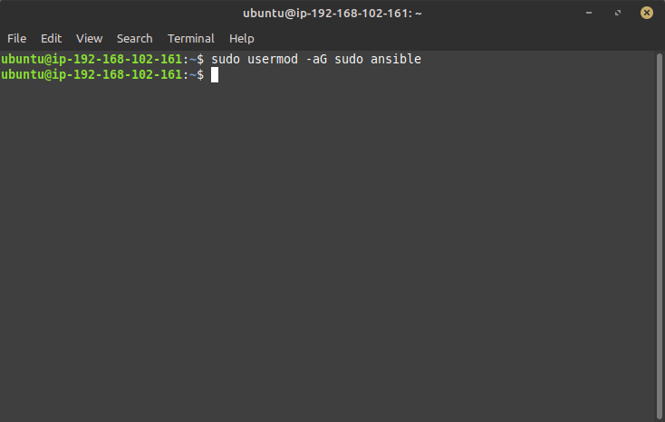

Switching to ansible user:

>> su ansible

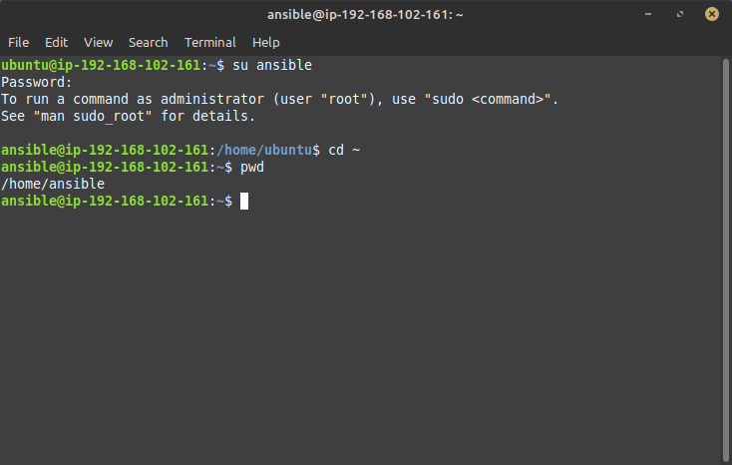

Now we have created ansible user on controller now we need to install and configure ansible on controller with following commands:

Installing ansible:

>> sudo apt install software-properties-common

>> sudo add-apt-repository --yes --update ppa:ansible/ansible

>> sudo apt update

>> sudo apt install ansible

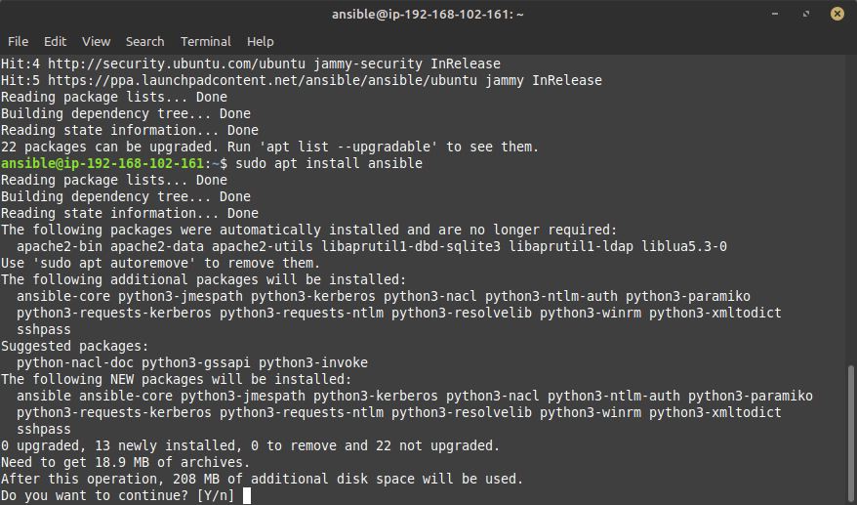

Verifying ansible installation

>> ansible --version

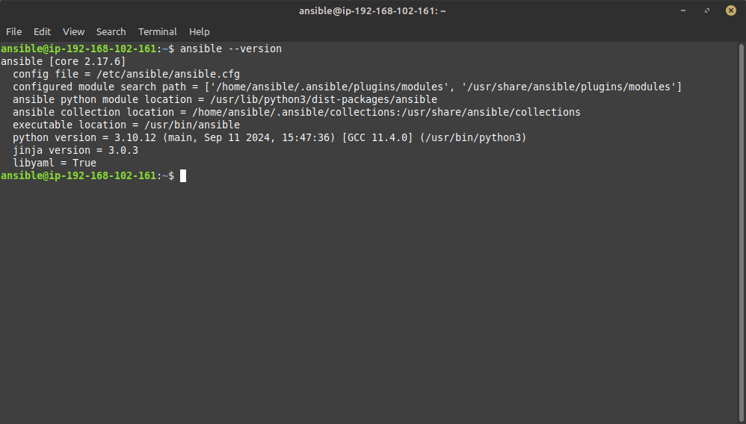

Basic Configuration:

>> cd /etc/ansible

>> sudo su

>> ansible-config init -t all --disabled > ansible.cfg

>> exit

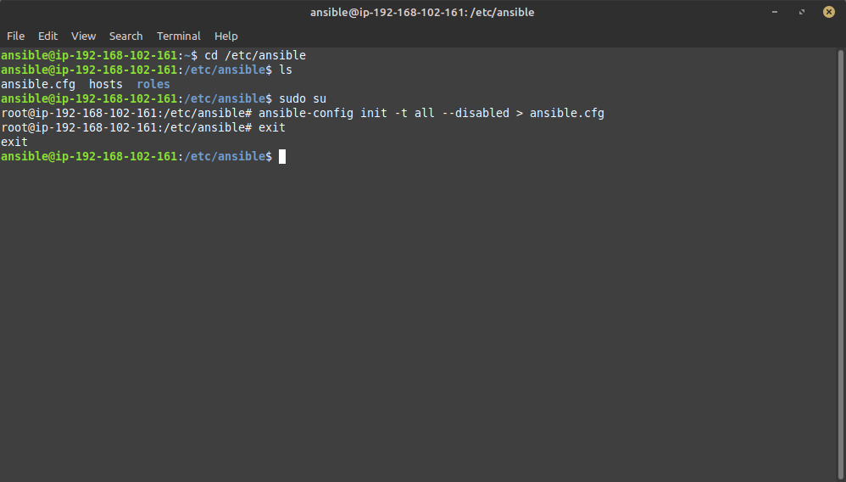

>> sudo nano /etc/ansible/ansible.cfg

#Added the following configuration settings after the [defaults]:

>> remote_user=ansible

>> host_key_checking=False

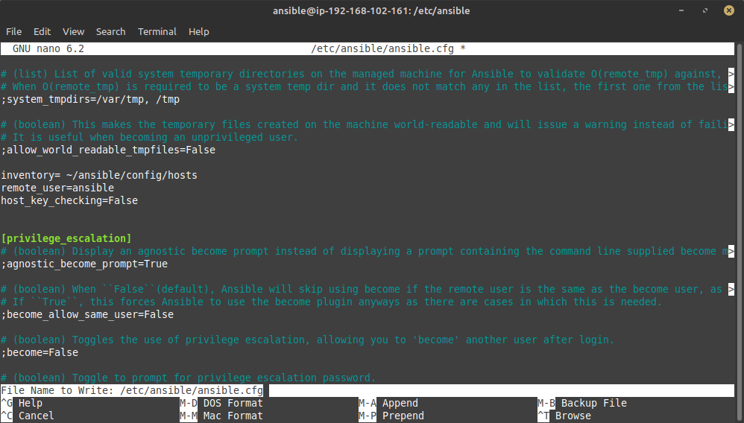

Adding host group & host IPs in inventory

>> sudo nano /etc/ansible/hosts

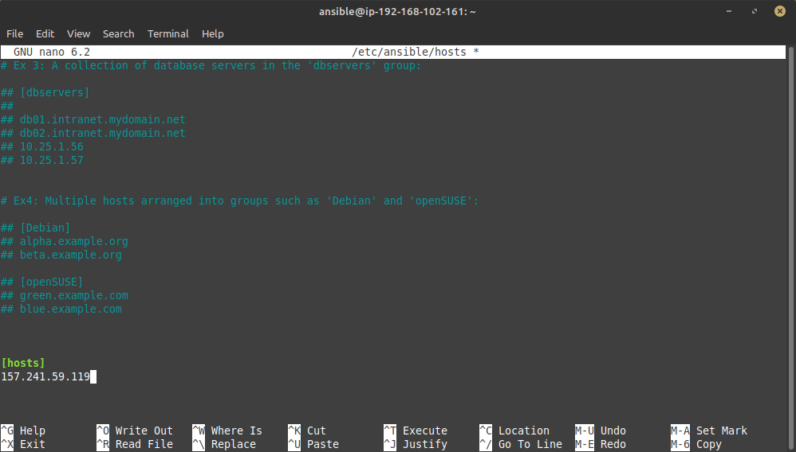

## Configuring Ansible hosts

Creating ansible user with sudo privileges and installing ansible in host systems with following commands (for debian based system):

>> sudo adduser ansible

>> sudo usermod -aG sudo ansible

>> su ansible

>> sudo apt install software-properties-common

>> sudo add-apt-repository --yes --update ppa:ansible/ansible

>> sudo apt update

>> sudo apt install ansible

Setting up password-less sudo privileges on host

>> sudo visudo

# Adding following in file

>> ansible ALL=(ALL) NOPASSWD: ALL

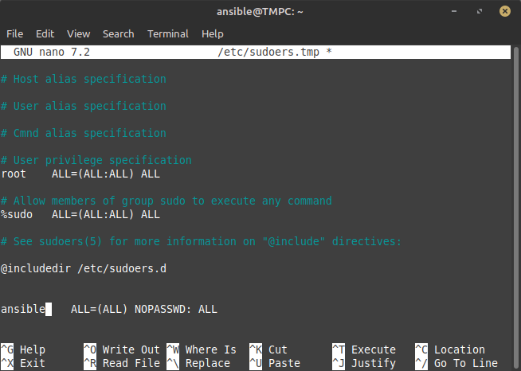

## Setting up SSH

Creating ssh-keygen for ansible user on ansible controller:

>> ssh-keygen -t rsa

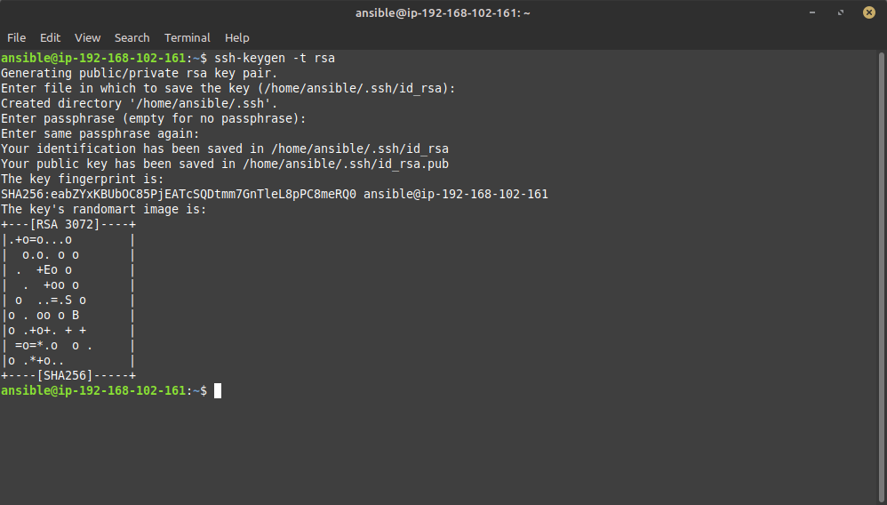

Viewing Ansible controller public ssh key

>>cat .ssh/id_rsa.pub

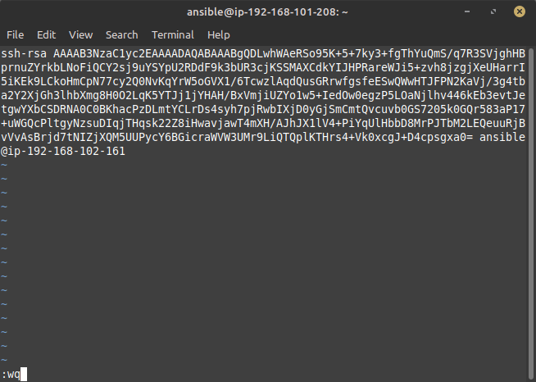

Sharing ssh with following command:

>>ssh-copy-id [ansible@host_ip](mailto:ansible@host_ip)

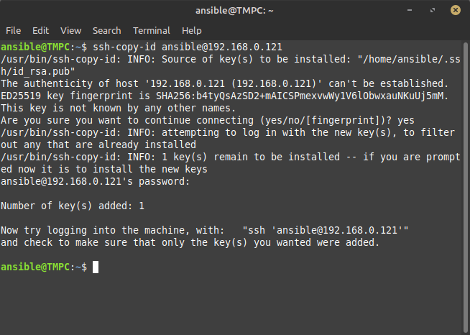

Verifying ssh sharing

>>ssh ansible@host_ip

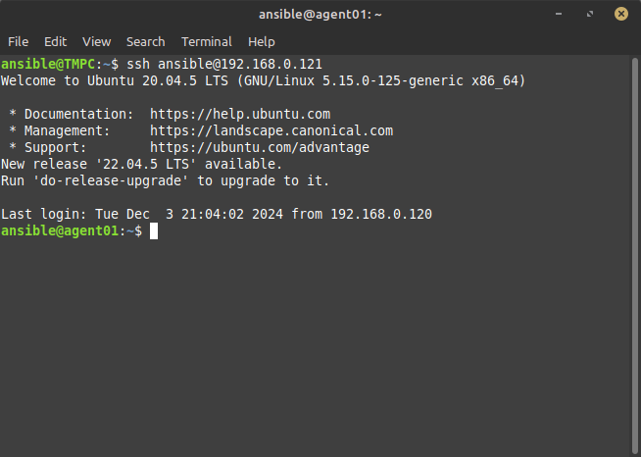

# Ansible ad-hoc Commands

In Ansible, an **ad-hoc command** is a one-time command that allows you to execute tasks on host systems without creating a full playbook. This is useful for quick, simple tasks. We can execute ad-hoccommands directly (without modules) with -a flag some example for those commands are followings:

>> ansible <hosts> -a "<shell command>"

i. ansible host -a "uptime"

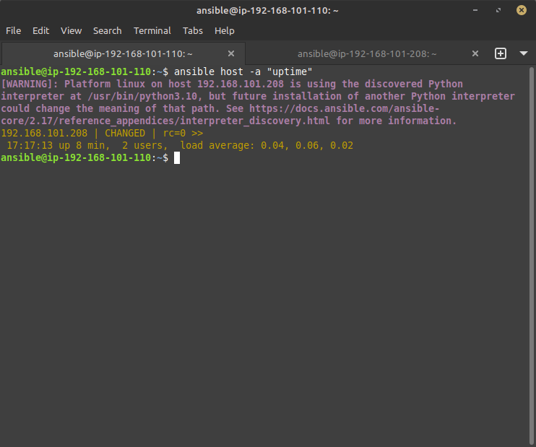

ii. ansible host -a "mkdir /home/ansible/test"

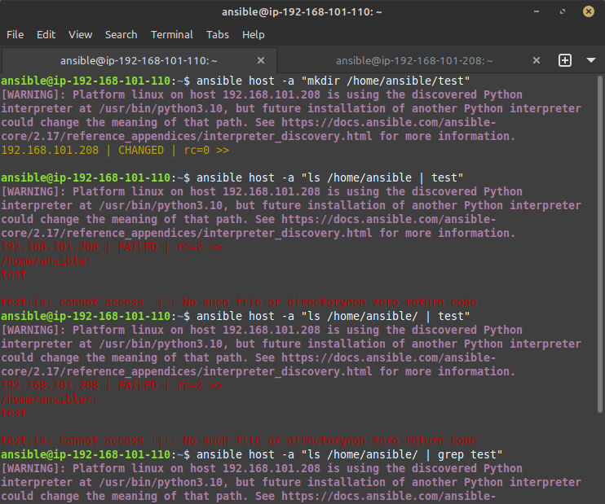

# Ansible Modules

We can also use predefined modules to perform task easily some example are followings:

>> ansible <hosts> -m <module> -a "<arguments>"

i. ansible all -m copy -a "src=/home/ansible/test.txt dest=/home/ansible/test.txt"

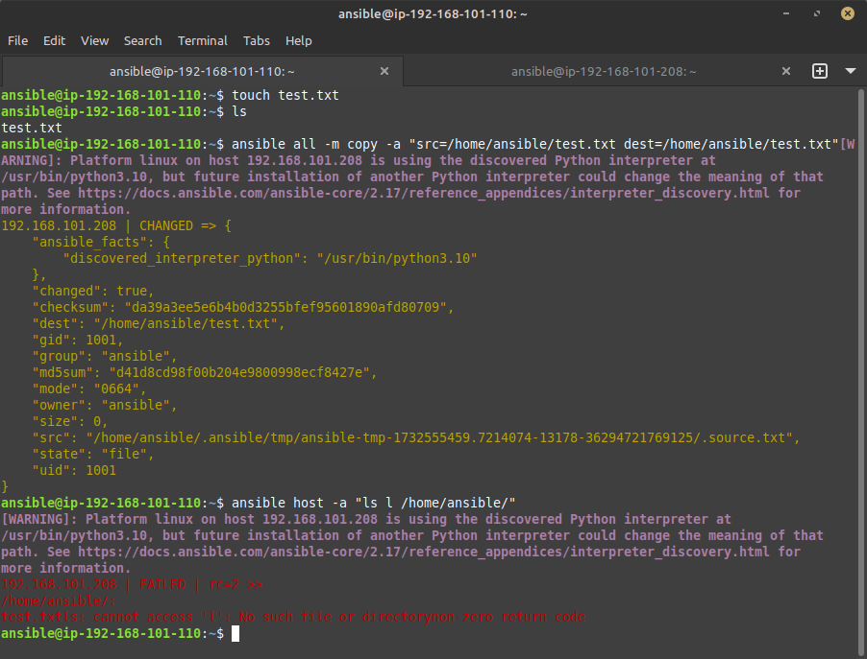

ii. ansible host -m shell -a "echo 'This is a test' >> /tmp/testfile"

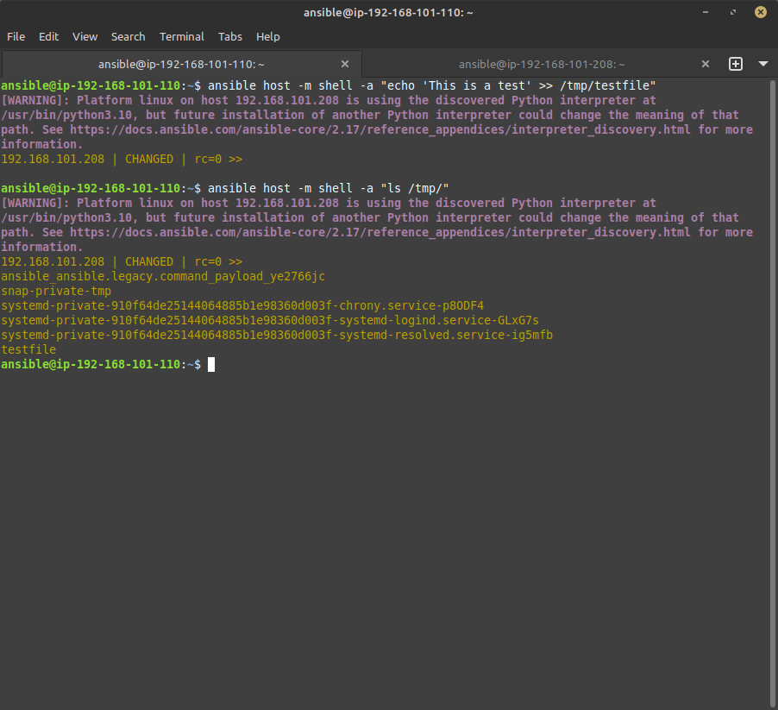

# Ansible Playbook

An Ansible **playbook** is a YAML file that defines a series of tasks to be executed on host systems. It allows execution of series of task to multiple host in one go.

## Key Elements of a Playbook:

* **Target**: Part of playbook that defines host & basic configurations.
* **Tasks**: Each task defines a specific action to be performed. Tasks use Ansible modules to perform actions.
* **Variables**: You can define variables to customize the behavior of your playbook.
* **Handlers: These** are special tasks that only run when notified by another task. They are typically used for tasks like restarting services or reloading configurations after changes.

**Following is example of YAML ansible playbook**

---

- host: webservers

become: yes # Run tasks with sudo privileges

tasks:

- name: Install nginx package

apt:

name: nginx

state: present

- name: Start nginx service

service:

name: nginx

state: started

Playbook can be executed with following command:

>> ansible-playbook <playbook.yml>

Ansible Playbook Examples:

i. Creating playbook01.yml which shows localhost‘s all the facts and variables: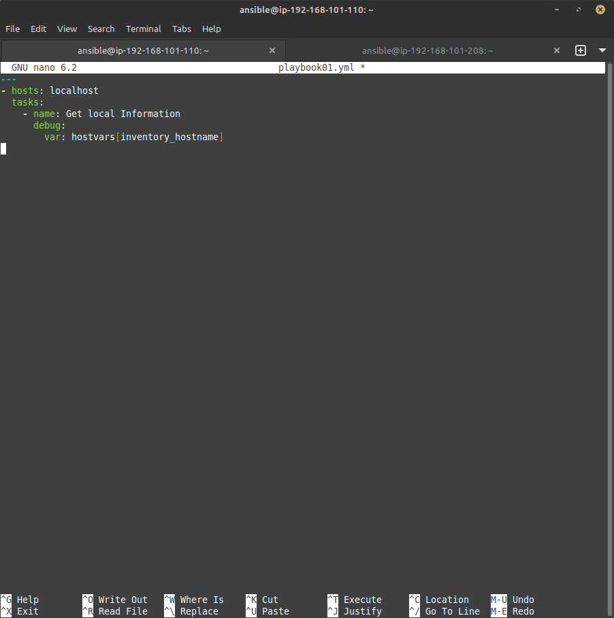

Running playbook:

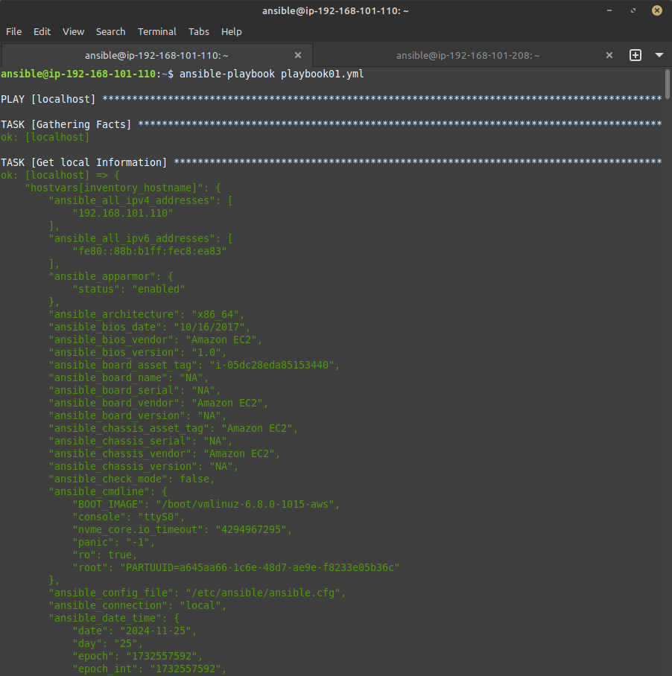>> ansible-playbook playbook01.yml

ii. Creating playbook03.yml which install/verify multiple apps on host system:

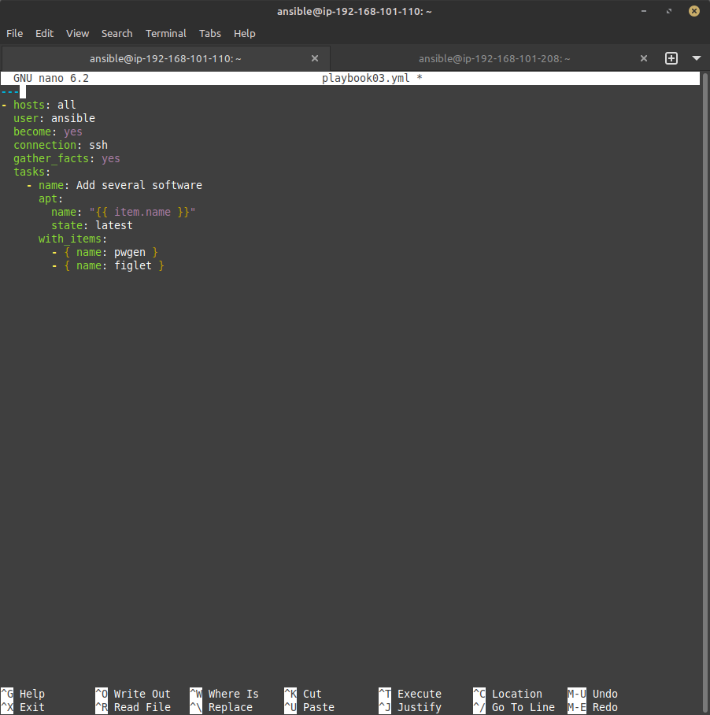

Running playbook:

>> ansible-playbook playbook03.yml -b –ask-become-pass

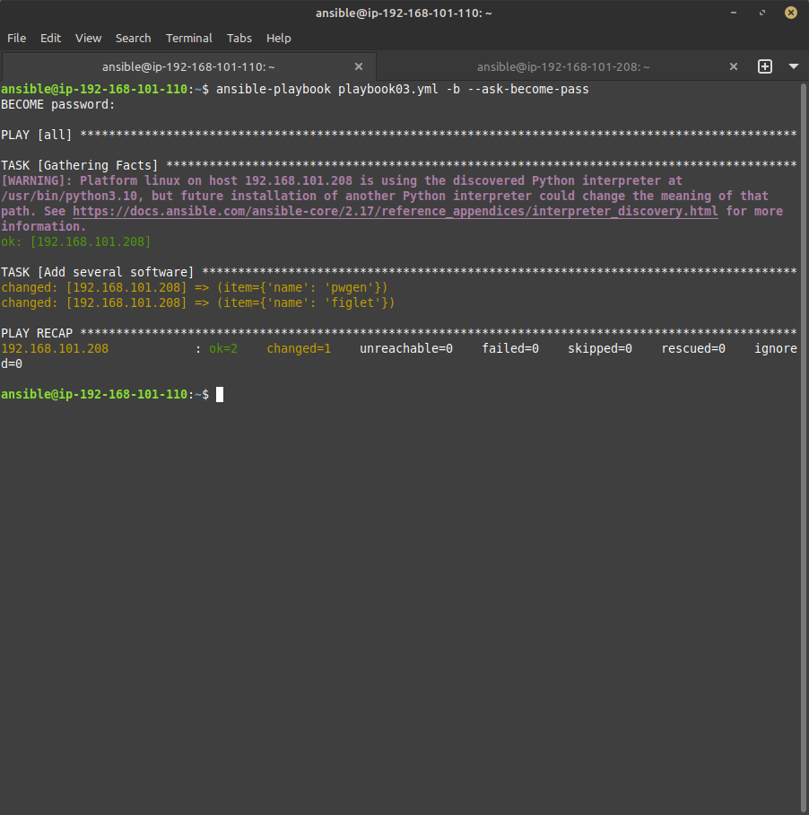

## Extra features of a Playbook:

### Condition (when):

The when statement in playbook is used to execute a task only when a certain condition is met. The condition is typically a logical expression or variable value.

**Example :**

- name: Install nginx if the condition is true

ansible.builtin.yum:

name: nginx

state: present

when: ansible_facts['os_family'] == 'RedHat'

### Loops:

You can use the loop directive to iterate over a list of items and apply the same task for each item.

**Example :**

- name: Install multiple packages

ansible.builtin.apt:

name: "{{ item }}"

state: present

loop:

- nginx

- git

- vim

### Tags:

Tags allow you to run specific parts of a playbook by assigning tags to tasks or plays. This helps you execute only certain parts of the playbook rather than running everything.

**Example :**

tasks:

- name: Install nginx

ansible.builtin.yum:

name: nginx

state: present

tags:

- install

## Ansible Vault:

Ansible Vault is a feature that allows you to securely store and manage sensitive data, such as passwords, API keys, and private keys, within Ansible playbooks, inventory files, or variables. Vault ensures that this sensitive information is encrypted and can be easily decrypted when needed during playbook execution.

### How to Use Ansible Vault:

1. **Creating an Encrypted File**

You can create an encrypted file using the ansible-vault create command. For example, to create an encrypted file called secrets.yml:

>> ansible-vault create secrets.yml

This command will prompt you for a password, which you will need to decrypt the file later.

**2. Viewing an Encrypted File**

To view the contents of an encrypted file, use the ansible-vault view command:

>> ansible-vault view secrets.yml

**3. Editing an Encrypted File**

If you need to edit an encrypted file, you can use the ansible-vault edit command:

>> ansible-vault edit secrets.yml

**4. Executing Encrypted File**

To run the playbook that includes a vault-encrypted file, you would provide the vault password using the --ask-vault-pass option.

>> ansible-playbook --ask-vault-pass secrets.yml